In this experiment we did coding to glow led which is setted up on the breadbord.

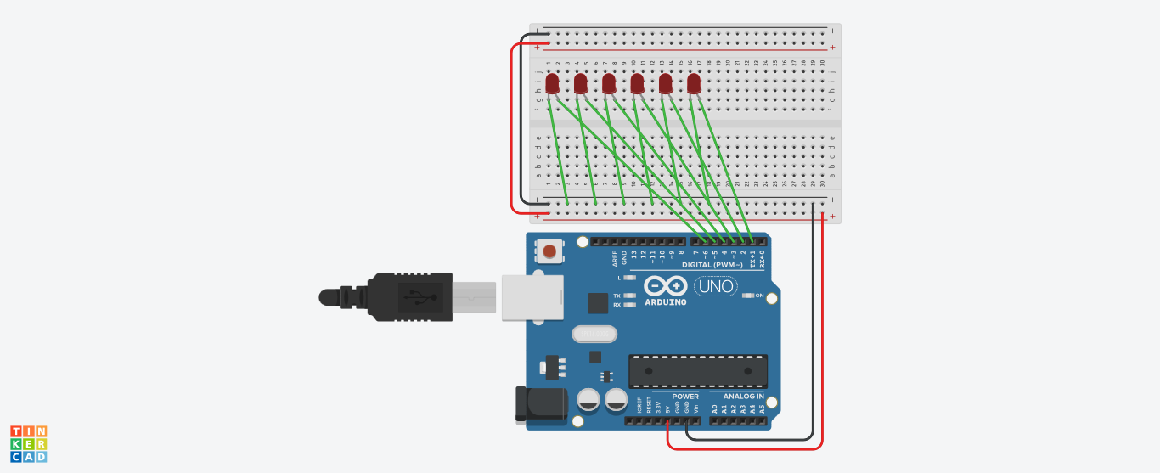

***Learning and observations:***

The coding is done by the help of the computer and instuction is provided to the Arduino uno board.Arduino is a single-board microcontroller meant to make the application more accessible which are interactive objects and its surroundings.This micro controller gives the valid instruction to the elements fitted on the breadboard according to coding done on software.

***Precautions:***

1. The software used for the coding should be perfect and no errors should exist like syntax and logical errors etc.

2. Connections shouldn't be loose.

3. Positive and negative should be connected in accurated places.

***Problem and troubleshooting:***

1-The incorrect coding shouldn't exist as it creates problems in the working of hardware. This can be corrected by learning C++ and practicing

it .

2-Hardware should be properly fitted on the Breadboard or

they might get fuse or get damaged .

3-Arduino wire must be checked if they are loose or not. And

the ports should be cleansed before using ,they might

cause problem in future.

***Learning Outcome:***

From this experiment we learned how to code in the software . This project was the base for the upcoming project we are going to do in upcoming semester.In this project we learned how to glow a LED bulb and how to code it on the software.